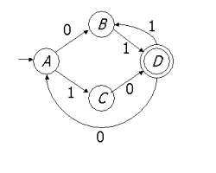

COMPONENTS:
- The ways to get from A to D without going through D ()
- The ways to get from D to itself, without going through A ()
- The ways to get from A to itself, without going through A ()

REGULAR EXPRESSIONS:

